Prunus Serotina “Black Cherry Tree”
Prunus serotina, commonly called black cherry, wild black cherry, rum cherry, or mountain black cherry, is a deciduous woody plant species belonging to the genus Prunus. The species is widespread and common in North America and South America.
Black cherry is not usually cultivated as an ornamental plant, but it seeds itself readily and often escapes into landscapes. It is a valuable forestry plant because the wood is prized for carpentry.
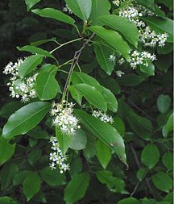
Description:
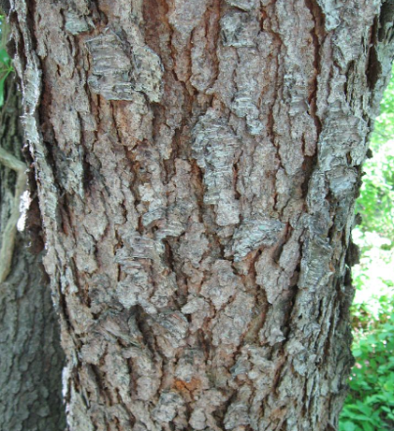
Prunus serotina is a medium-sized, fast-growing forest tree growing to a height of 50–80 feet. Leaves are 2" to 5" in length, ovate-lanceolate in shape, with finely toothed margins. Fall leaf color is yellow to red. Flowers are small, white and 5-petalled, in racemes 4" to 6" long which contain several dozen flowers. The flowers give rise to edible reddish-black "berries" . Hardy in zones 3 – 9.
A mature black cherry tree can easily be identified in a forest by its very broken, dark grey to black bark, which has the appearance of very thick, burnt cornflakes. However, for about the first decade or so of its life, the bark is thin, smooth, and banded, resembling that of a birch. It can also quickly be identified by its long, shiny leaves resembling those of a sourwood, and by an almond-like odor released when a young twig is scratched and held close to the nose.

Ecology and Cultivation
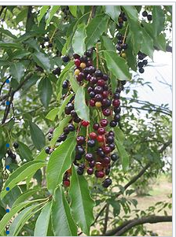
In the Midwest, it is seen growing mostly in old fields with other sun-loving species, such as black walnut, black locust, and hackberry. It has been described as “formerly a forest tree, now abundant as a weed-tree of roadsides, waste land, and forest-margins". It is a moderately long-lived tree, with ages of up to 258 years known, though it is prone to storm damage, with branches breaking easily; any decay resulting, however, only progresses slowly. Seed production begins around 10 years of age, but does not become heavy until 30 years and continues up to 100 years or more. Germination rates are high, and the seeds are widely dispersed by birds who eat the fruit and then excrete them. Some seeds however may remain in the soil bank and not germinate for as long as three years.
Prunus serotina was widely introduced into Western and Central Europe as an ornamental tree in the mid 20th century, where it has become locally naturalized. It has acted as an invasive species there, negatively affecting forest community biodiversity and regeneration.
Prunus serotina subsp. capuli was cultivated in Central and South America well before European contact.
Biochemistry
Like apricots and apples, the seeds of black cherries contain compounds that can be converted into cyanide, such as amygdalin.
The foliage, particularly when wilted, contains cyanogenic glycosides, which convert to hydrogen cyanide if eaten by animals. Farmers are recommended to remove any trees that fall in a field containing livestock, because the wilted leaves could poison the animals. Removal is not always practical, though, because they often grow in very large numbers on farms, taking advantage of the light brought about by mowing and grazing. Entire fencerows can be lined with this poisonous tree, making it difficult to monitor all the branches falling into the grazing area. Black cherry is a leading cause of livestock illness, and grazing animals access to it should be limited.
Uses
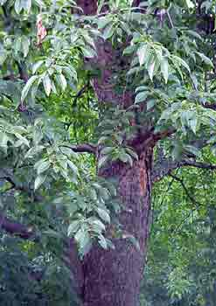
The fruit of black cherry has a bitter-sweet flavor and is used to make jelly and wine. Birds, squirrels, deer, raccoon, black bears, ruffed grouse, opossum and turkey are among the animals that eat the fruit of black cherry. The bark, leaves and twigs of this tree are poisonous to livestock, although deer can eat the leaves without harm. Wilted leaves of black cherry are more poisonous than fresh leaves.
POISONOUS PARTS: Wilted leaves, twigs (stems), seeds. Highly toxic to humans and herbivorous mammals. May be fatal if ingested. Symptoms include gasping, weakness, excitement, pupil dilation, spasms, convulsions, coma, respiratory failure.
The wood of Prunus serotina is also used for cooking and smoking foods, where it imparts a unique flavor.
Inner bark used in cough syrups, sedatives, and tonics.
Prunus serotina timber is valuable; perhaps the premier cabinetry timber of the U.S., traded as "cherry". High quality cherry timber is known for its strong orange hues and high price. Low-quality wood, as well as the sap wood, can be more tan.
Honey bees and bumble bees value the flowers.

Kathy Glockner
June 4, 2018

