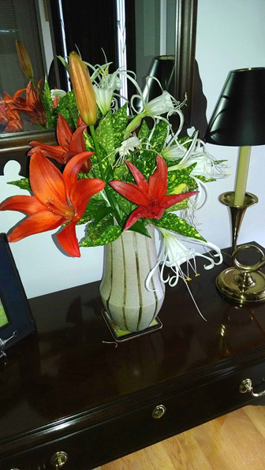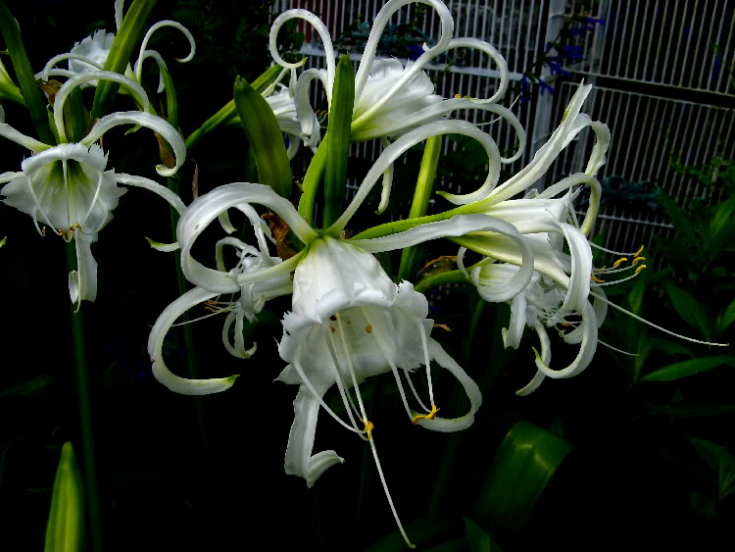
Peruvian Daffodil
Peruvian daffodil (Hymenocallis narcissiflora)
Synonyms: H. calathina Genus: Hymenocallis
This bulb blooms in early summer (mid-June in my garden), with striking, sweetly-scented white or yellow flowers that appear on leafless stems up to 24 inches tall. Petals curve up to accent a daffodil-like cup, sometimes with green-striped tubes. Peruvian daffodil has long, strap-shaped, arching, dark green leaves.

Care: Part sun and moist, well-drained soil are best. Bulbs may be grown in the ground or in pots and should be planted with the neck and shoulders exposed. May withstand short spells around freezing temperatures. In the garden, plant in spring and dig up for winter. Protect bulbs from excessive moisture when dormant.

Landscape Interest: I planted a package of the bulbs I purchased at Lowes (Spring 2014) in my lower garden near the water using their taller frame as a punctuation marks in the garden. The Peruvian daffodil is an interesting flower shape for an arrangement and can stand alone as the focal point in a vase. They are very nice to feature in an Ikebana arrangement. Only downside is that they should be dug up in the fall for indoor storage. Hardy in zone 8-10.

