Perennial Geranium (Cranesbill)
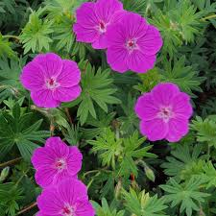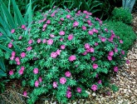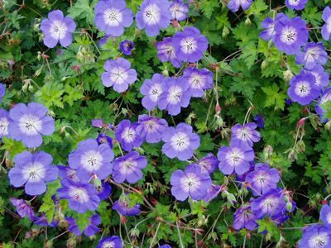

Geraniums were once considered the "must have" plant for English gardens and with over 400 species it wasn't long before cultivars developed popularity with gardeners worldwide. Buyers beware however as perennial geraniums are not related to annual geraniums which are actually in the genus Pelargonium. A true geranium is a cold hardy perennial that will prove to be long-lived and add years of beauty and graceful charm to any garden.

Plant Highlight: Geranium (Cranesbill) Botanical and Common Name: Perennial Geranium is also called Cranesbill because of the shape of the seed pods once the petals have faded. Seed heads snap open like bird beaks to release the seeds.
Hardiness Zones: Geranium is hardy in zones 4 - 9.
Bloom Time & Color: Most hardy geraniums bloom for months beginning around May and continuing until October or November. If the cup shaped flowers fade in the summer heat trim the plant back and water deeply to encourage repeat blooming.
Plant Category: A true geranium is a hardy perennial. Originally cultivated from native alpine plants they are very cold hardy.
Many cranesbill geraniums have slightly sprawling growth habits that become lanky with over fertilizing. Geraniums come in sizes ranging from 6-8" all the way to 3' or taller. Check specific cultivar information for details.Geraniums prefer light shade to full sun except in hot humid areas where part shade is best. Well-drained soil is best. Easy to keep, geraniums seldom require any extra care at all except some fertilizing at the beginning of the growing season. Fertilize once at the beginning of the growth season to prevent lanky growth that will result with too-frequent fertilizing. Many Geraniums set seed and it is the seedpods that give cranesbill the common name. Some hybrids are sterile or do not come true from seed so divisions can be taken or cuttings grown for propagation that holds true. Cuttings can be difficult to root so division is easier for propagation reasons, but seldom necessary for plant heath.
If you would like a perennial geranium, please contact Kathy Glockner at kglockner@md.metrocast.net to make an appointment to dig up a few plants. I will be renovating a portion of my perennial bed in the next two weeks.

