Eucomis or Pineapple Lilly
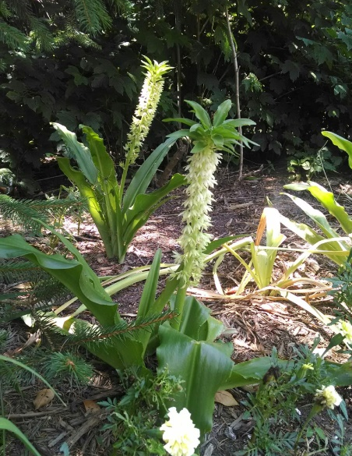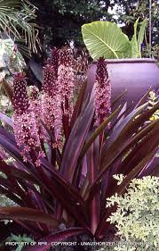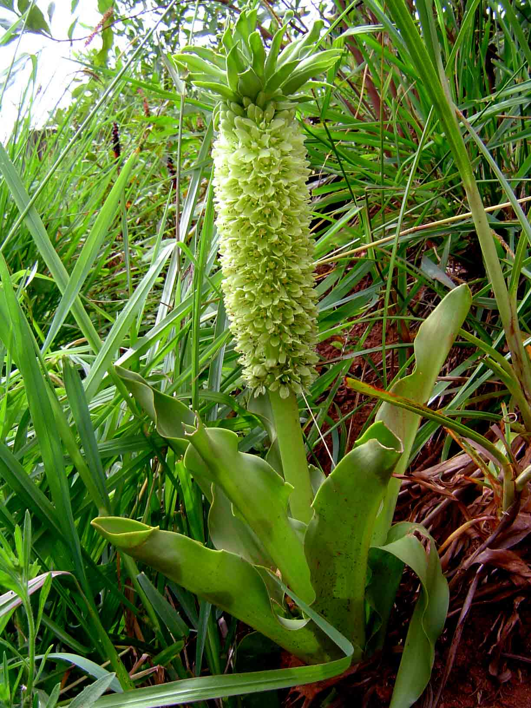
Background: This South African native has tropical-looking, fleshy leaves with flower spikes that appear to be miniature “pineapples” at the top of each stem. Hundreds of waxy, one inch starry flowers are perfectly shaped, mostly edged in maroon and begin opening from the bottom up. In our Zone 7 Maryland gardens, they will start to bloom in late June and can hold their own until the fall. An excellent bulb specimen to enter in the County Fair.
Planting Site: Useful in bright sun with regular water during active growth, but protect from saturating winter-to-spring rains. Bulbs emerge late in spring, grow rapidly and flower for 6 weeks with interesting seedpods continuing to frost. Full sun preferred, but light shade in hot climates is acceptable. It is perfectly normal for leaves to "wilt" a bit during the hot midday, but don't worry, they perk up again the next morning.
A marvelous cut flower, stems stay fresh for weeks. Hardy to USDA Zone 6 to 7 with insulating mulch or lift bulbs to store in a frost-free location. Eucomis are long-lived and although they prefer to be left undisturbed, offsets can be detached from the mother bulb in fall, taking an additional two years before the babies flower.
My favorite is Sparkling Burgundy. I first noticed this plant at the Lewis Ginter Botanic Garden several years ago, then found them for sale through Brent and Beck Bulbs. The white flowering variety can be found in Lowes and other stores in the fall. This outstanding cultivar boasts dark burgundy leaves that slowly change to olive green, and then revert back dramatically as the flowers fade. The flowers form on 20- to 30-inch stalks bearing bottle-brush-like wands of tight, smoky pink florets, which are crowned by tufts of purple bracts. As the common name implies, these unusual and magnificent inflorescences are reminiscent of pineapples.
Care: Fall or spring planting. Plant bulbs 6 inches deep, in fertile, well-drained soil in full sun. In cooler climates, plant in containers for garden display and overwinter in a frost free location. Water freely in active growth; they do best if dry when dormant.

