Common Chickweed
Common chickweed (Stellaria media) is an annual, but it tolerates cold weather so well that it can survive winter in mild climates. A member of the Pink or Carnation family (Caryophyllaceae), it is related to some of our prettiest wildflowers.
Seedling Description
Common chickweed seedlings are light green or yellow-green. The hypocotyl (stem below the seed leaves) is smooth and slender, about 1/3 inch (8 mm) long, and often lies flat soon after leaves begin to form. The two seed leaves (cotyledons) are smooth, oblong to lanceolate, and 1/8 to 3/8 inch (3 to 9 mm) long. Cotyledons are attached to the stem by leaf stalks (petioles) about 1/8 inch long.
Biology
Technically, common chickweed is an annual, but it tolerates cold weather so well that it can survive winter in mild climates. It has a shallow, fibrous root system, reproduces by seed, and grows in a thick, springy mat as its stems spread over the ground and form roots at the nodes.
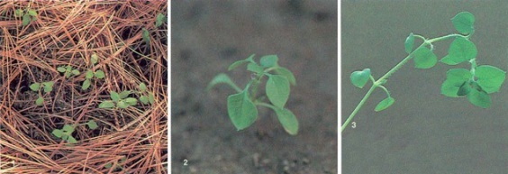
Stems grow 3 to 15 inches (8 to 38 cm) long and are widely branched. The stems are limp and prostrate or only slightly erect, so chickweed must lean on other plants for support. A single line of white hairs grows along the stem. The line is not continuous, but alternates between nodes from one side of the stem to the other.
Each plant produces 2,500 to 15,000 seeds. The seeds are less than 1/16 inch (1 mm) long, and dull red or dark brown. They ripen five to seven weeks after the parent plant germinates. Seeds that ripen in warm weather are not dormant and can sprout immediately. Those that ripen in cold weather must wait until the following spring, when alternating temperatures break their dormancy. Seeds may remain viable in soil for up to ten years.
Seeds germinate best when very close to the soil surface, and not at all when below ¾ inch (2 cm) deep. Although common chickweed grows most successfully in moist soil, its seeds can also sprout in dry soil.
Control
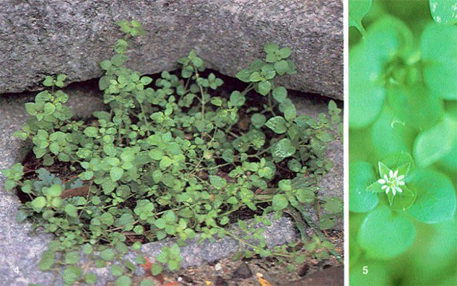
In gardens and row crops, clean cultivating early—when both vegetable and weed seedlings are small—is effective.The best time to control chickweed is in the fall when legumes are dormant and chickweed is still growing, or in early spring when legume regrowth is less than 2 inches (5 cm) tall.In lawns, establishing and maintaining healthy sod is the best defense against chickweed. If chickweed becomes a widespread problem in turfgrass, it can be controlled by chemical herbicides. To rid a lawn of a few scattered plants, any soluble nitrogen fertilizer will do. Crushing the chickweed slightly by stepping on it and then sprinkling on a little fertilizer will burn the weed enough to kill it. Some grass tips may be burned in the process, but the grass will revive because its roots are perennial. The chemicals then wash down into the soil and fertilize the lawn.

