Brugmansia
GENUS/SPECIES: Brugmansia (Angel’s Trumpet)
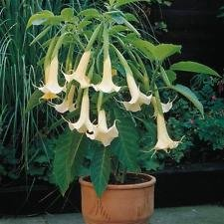
- Brugmansia is a genus of seven species of flowering plants in the family Solanaceae. They are woody trees or shrubs, with pendulous flowers, and have no spines on their fruit. Their large, fragrant flowers give them their common name of Angel's Trumpets, a name sometimes used for the closely related genus Datura. Flowers come in white, yellow and peach.

GENERAL DESCRIPTION

- Brugmansias are frequently confused with or thought to be the same as daturas, which are also commonly called Angel Trumpets. This is an incorrect assumption though. Brugmansia and daturas are not directly related to one another (they are listed in two separate genus). The brugmansia is a woody tree, while the datura is an herbaceous shrub. The two different angel trumpets can be distinguished by the direction of the flowers. In brugmansias, the flower hangs down. In daturas, the flower stands upright.

- Many people look at brugmansias and assume that they can only be grown in tropical climates. While it is true that brugmansias are tropical trees, they are actually very easy for someone in a colder climate to grow and enjoy. Brugmansias can be easily grown in containers.

- All parts of Brugmansia are potentially poisonous, with the seeds and leaves being especially dangerous.

COUNTRY OF ORIGIN AND/OR HABITAT
- Brugmansia are native to tropical regions of South America, along the Andes from Venezuela to northern Chile, and also in south-eastern Brazil. They are grown as ornamental container plants worldwide, and have become naturalized in isolated tropical areas around the globe, including within North America, Africa, Australia, and Asia

USES
- Brugmansia are easily grown in a moist, fertile, well-drained soil, in sun to part shade, in frost-free climates. They begin to flower in mid to late spring in warm climates and continue into the fall, often continuing as late as early winter in warm conditions.
CULTURE
Soil
- Moist, fertile and well-drained soil. Prefers acidic soil but will grow in alkaline.
- Fertilize regularly (once a month in the summer) to promote flower growth.

Planting
- After winter dormancy, bring outside in a sunny area in a pot. Plant your brugmansia in a large container, at least two feet in diameter. Your container brugmansia can go outside when the nighttime temperatures stay above 50 F (10 C.) and can remain outside until the fall when the nighttime temperatures start to fall below 50 F (10 C.).

- Be sure to keep your container thoroughly watered while you keep it outside. They do need a lot of water and your container brugmansia may need to be watered up to twice a day.
Care and Maintenance
- Most brugmansias will not grow to their full height if they are grown in a container. At the most, the typical container grown brugmansia will reach a height of about 12 feet. Of course, if this is too high, a container grown brugmansia tree can be easily trained into a smaller tree or even a shrub size. Pruning your container brugmansia to a desired height or shape will not affect the size or frequency of the flowers.
- Water frequently in summer months.
- Generally does not need staking.
- Mulch in a container to retain water.

Diseases No prevalent problems.
Insect Pests and Control
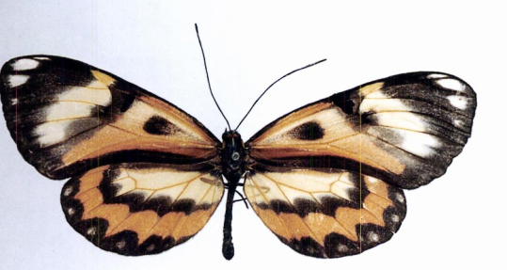
- One interesting example of plant/animal interaction involves the butterfly Placidula euryanassa, which uses Brugmansia suaveolens as one of its main larval foods. It has been shown that these can sequester the plant's tropane alkaloids and store them through the pupal stage on to the adult butterfly, where they are then used as a defense mechanism, making themselves less palatable to vertebrate predators.

Propagation
- Most Brugmansia are fragrant in the evenings to attract pollinating moths. One species lacking scent, the red-flowered Brugmansia sanguinea, is pollinated by long-billed hummingbirds.
- Brugmansia have two main stages to their life cycle. In the initial vegetative stage the young seedling grows straight up on usually a single stalk, until it reaches its first main fork at (2.6–4.9 ft) high. It will not flower until after it has reached this fork, and then only on new growth above the fork. Cuttings taken from the lower vegetative region must also grow to a similar height before flowering, but cuttings from the upper flowering region will often flower at a very low height.
Post-season care
- Store your plant over the winter in a basement, crawl space or garage. Or, you can bring it into your house. When storing dormant, I let mine go without water all winter and they re-emerge in the spring. Watering once a month is an option.

SOURCE – Many mail order catalogs offer Brugmansia plants. Suzanne Patterson has cuttings rooted and offering for sale today with the proceeds to benefit the scholarship fund.

