Basil
Lamiaceae, in the genus: Ocimum. Scientific name is "Ocimum basilicum."
The king of herbs, basil is one of the ancient and popular herbal plants brimming with notable health-benefiting phytonutrients. This highly prized plant is revered as "holy herb" in many cultures all around the world.
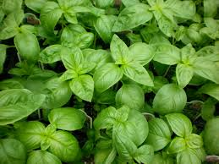
Basil needs 6 to 8 hours of sun, and in our hot summers, can benefit from some afternoon shade. Set out plants at least 2 weeks after the last frost in spring; summer planting is okay, too. Space at the distance recommended on the label, which is generally 12 to 18 inches apart. Plants are very frost sensitive, so keep plants protected in case of a late cold spell. Basil likes rich, moist, but well-drained soil with a pH of 6 to 7.
Because it is harvested continually for lots of leaves, it needs a little fertilizer. When planting, add plenty of organic nutrients from compost, blood meal, or cottonseed meal to the soil. Feed with plant food every couple of weeks to help keep tender new leaves coming on as you pinch back the stem tips.
If planting in a container, use a large pot to keep the plants from drying out quickly in hot weather. You may also want to add mulch around the plants to help keep the soil moist and extend the time between waterings.
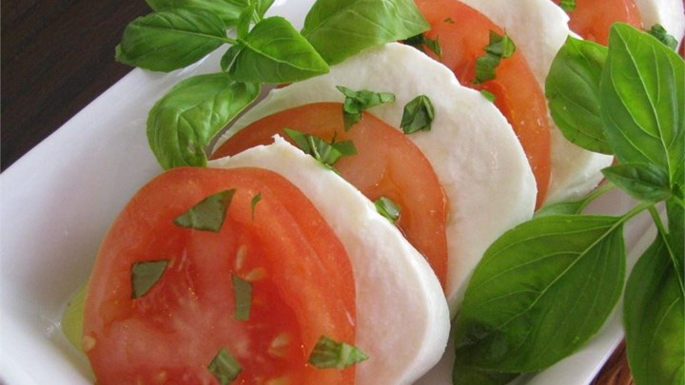
Basil is a common ingredient in Italian style dishes, such as Pesto and Mozzarella Salad.
http://allrecipes.com/recipe/13937/pesto/
Tomato and Mozzarella Salad is an easy appetizer or side dish.
http://allrecipes.com/recipe/222659/tomato-mozzarella-salad/

Be sure to grow some this summer and enter a cutting in the County Fair Flower Show!

