Alocasia and Colocasia Plants
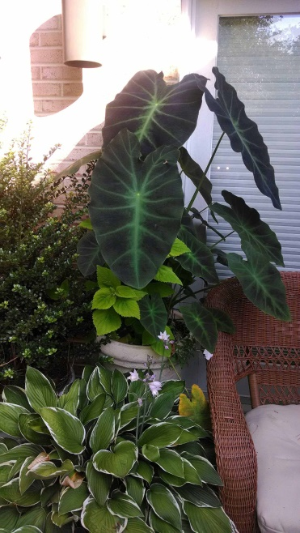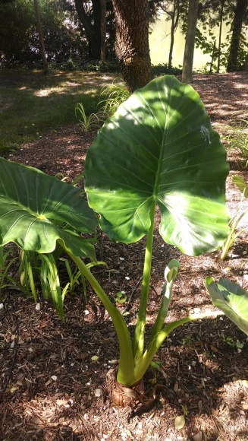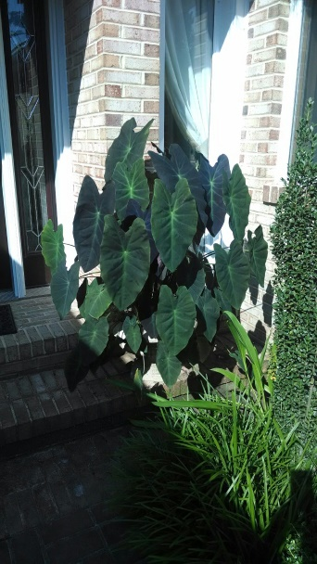
Background: Alocasia and Colocaisa are commonly referred to as Elephant Ear, the huge green to deep purple leaves bear a likeness to the ears of an elephant. They are hardy in zones 8 – 11 so they must be dug up in the fall and moved indoors in our zone 7 climate. Alocasia leaves generally point up (third from the left) while colocasia point downward.
Location: Alocasia and Colocasia will adjust its size according to the amount of sun it receives. The more sun it receives the smaller it will be, the less sun it recieves the larger it will become "to a point". In some cultivars the difference can be staggering. The green leaf cultivars such as Calidora and California love water these types will grow well along side a pond or lake. Other cultivars prefer drier soil and if kept moist will develop crown rot these varieties are Longiloba, Amazonica and other like kinds. When growing the green type in the home landscape recommend morning sun and afternoon shade in an area with an ample water supply.This will produce huge, broad leaves in Alocasia Calidora. They do best in a soil rich in organic fertilizer with composted manure. Compost should be worked into the soil at a ratio of 1/40 lb bag per 16 sq. ft. this ratio will produce the best results. A slow release balanced fertilizer applied in the spring will provide nutrients throughout the growing season. Most Alocasia and Colocasia prefer high humidity and grow larger faster in humid conditions.
Overwinter Care: When fall arrives the plants should be allowed to die back by restricting water or the onset of frost at this point the bulbs can be brought in for the winter in zones 7 or above or left in ground in zones 8 and higher.
What is the difference between Alocasia and Colocasia? Alocasia and Colocasia are both plants of the Araceae family. Both species have very large leaves, and both are called elephant’s ears. Alocasia is a perennial in U.S. Department of Agriculture plant hardiness zones 8b to 11. Colocasia has an almost identical growing zone, as it is a perennial in USDA plant hardiness zones 8 to 11. The leaves of these plants are the most obvious difference. The stiff leaf stems, or petioles, of Alocasia extend into the leaves. This causes the leaves to follow the line of the petioles. As a result, most Alocasia leaves tend to point upwards. Some Alocasia varieties have leaves that extend horizontally. By contrast, the petioles of Colocasia connect down from the notches in the leaves. This enables the leaves to droop or hang at a downward angle. This visual distinction makes it easy to tell these plants apart: If the leaves point up, the plant is probably an Alocasia; if the leaves point down, it’s probably a Colocasia.

